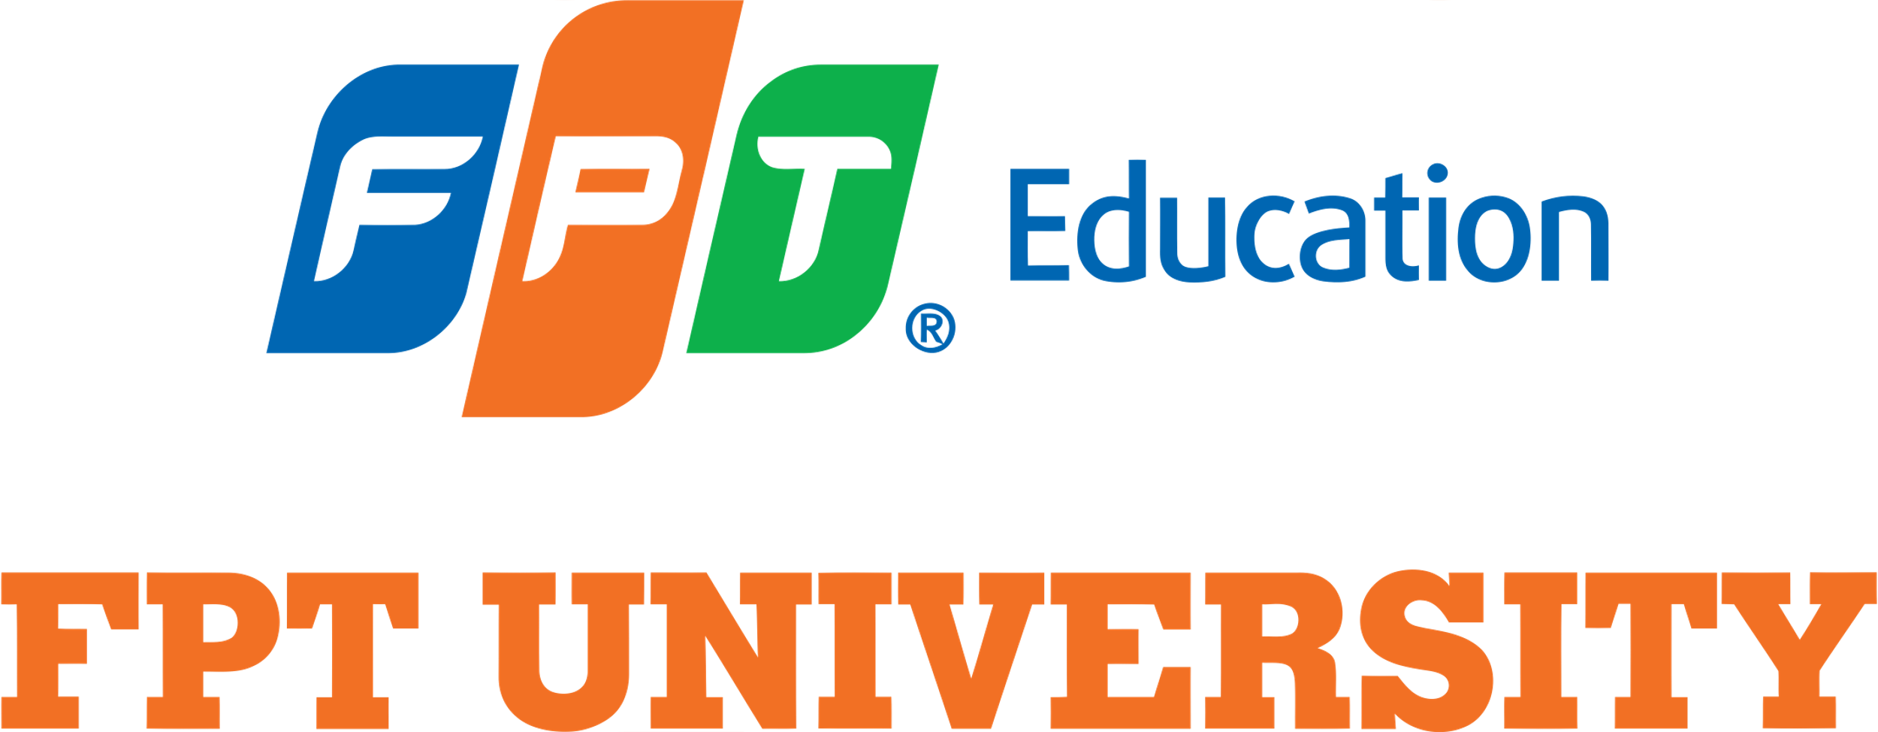

CASE STUDY 2 WEEK 8

Fundraising process for Startups (Y Combinator, 2018)
1. Preparation:
- Business Plan: develop a comprehensive business plan outlining your business model, market analysis, financial projections, and vision.
- Pitch Deck: create a compelling pitch deck highlighting your problem, solution, market opportunity, business model, traction, and team.
- Financials: understand your financial statements and projections in detail.
2. Identifying investors:
- Research: find investors who focus on your industry and stage.
- Networking: attend events, pitch competitions, and use platforms to connect with potential investors.
3. Crafting the pitch:
- Value proposition: clearly explain the problem your product solves and its unique value.
- Market opportunity: demonstrate the size and growth potential of your target market.
- Team: highlight the experience and strengths of your team.
4. Pitching to investors:
- Practice: refine your pitch and ensure clarity and confidence.
- Presentation: be prepared to answer questions about your business model, financials, and growth strategy.
- Follow - up: send thank - you notes and any additional requested information.
5. Negotiating terms:
- Valuation and equity: understand your company’s valuation and the equity you are offering.
- Term sheet: negotiate key terms including control rights, liquidation preferences, and anti-dilution provisions.
- Legal advice: seek professional help to navigate and finalize terms.
6. Closing the deal:
- Due diligence: prepare for investor scrutiny of your business operations, financials, and legal standing.
- Final negotiations: agree on final terms and conditions.
- Signing agreement: formalize the investment deal through legal documentation.
7. Post - funding:
- Effective use of funds: allocate capital towards growth, achieving key milestones, and strategic initiatives.
- Investor relations: maintain transparent and regular communication with investors.
- Continuous improvement: use feedback and data to iterate on the product and business strategy.

Case study: Robinhood
1. Preparation (Y Combinator, 2018):
- Business plan: developed a comprehensive plan focusing on commission - free trading.
- Pitch deck: highlighted the disruptive potential of commission-free trading in a traditionally fee-based industry.
2. Identifying investors (Y Combinator, 2018):
- Research: targeted investors interested in fintech and consumer technology.
- Networking: leveraged connections within the tech industry and Silicon Valley.
3. Crafting the pitch (IvyPanda, 2020):
- Value proposition: emphasized accessibility and democratization of finance.
- Market opportunity: showcased the large, untapped market of young, tech-savvy investors.
4. Pitching to investors (IvyPanda, 2020):
- Seed funding: raised $3 million from Google Ventures, Andreessen Horowitz, and other prominent investors.
- Series A and beyond: secured $13 million in Series A, followed by additional rounds, including $50 million in Series B and $110 million in Series C.
5. Negotiating terms (Nasdaq, 2019):
- Valuation and equity: negotiated favorable terms to balance funding with equity retention.
- Term sheets: carefully reviewed terms to ensure alignment with long - term goals.
6. Closing the deal (Nasdaq, 2019):
- Due diligence: prepared thorough documentation for investor review.
- Final agreements: successfully closed multiple funding rounds through clear communication and strategic negotiation.
7. Post - funding (Nasdaq, 2019):
- Effective use of funds: Allocated capital towards user acquisition, product development, and expanding operations.
- Investor relations: maintained strong relationships with investors through regular updates and transparency.
- Continuous improvement: focused on innovation and expanding their product offerings to stay competitive.
References:
- Y Combinator. (2019). Modern Startup Funding. Retrieved from YC
- Y Combinator. (2018). Fundraising Fundamentals. Retrieved from YC
- Y Combinator. (n.d.). A Guide to Seed Fundraising. Retrieved from YC
- Ralston, G. (Moderator). (2019). A Conversation with Aileen Lee [Video]. YouTube. Retrieved from YouTube
- Nasdaq. (n.d.). A Closer Look: Robinhood Markets' Options Market Dynamics. Retrieved from Nasdaq
- Crunchbase. (n.d.). Robinhood Company Financials. Retrieved from Crunchbase
- IvyPanda, 2020. Robin Hood Management Case Study. [online] Available at: https://ivypanda.com/essays/robin-hood-management-case-study/ [Accessed 14 July 2024].

